ENG-8 with POWERS
Type-2: Six-Word Memoir Assignment

“Every life has a story and every story is special!”

What is a memoir? Memoir is related to the word “memory”. Our memories make up our life story and our life experiences. A memoir reflects who we are as a person.

Assignment Description: I challenge you to write your life story in six words; no less and no more. This year in ENG-8 we’ll begin to look at words more closely. In addition to a word’s meaning (denotation), we’ll look at the word’s structure (syntax), and the feelings or (connotation) associated with a word. It’s time to start looking at words and using words in a whole new way!

Requirements:
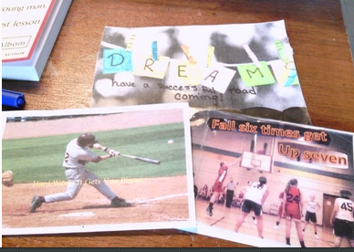
- Giant Index Card
- 6 word phrase about your life (related to your brainstorming).
- Grammatically correct
- Statement should NOT use the word “I”
- Includes a picture or a symbol related to the 6 words.
- The presentation should be high quality work that demonstrates neatness, color, school appropriateness, grammatically flawless, and includes strong word choice.

Class Compilation: Remember, please put some thought and effort into your assignment. Your finished product will be displayed in our classroom as well as posted in your first blog entry for ENG-8!

Resources:
Visual Thesaurus- Look up synonyms of a word.
https://www.visualthesaurus.com/

Grade: 30 pts. (Type 2) Writing Assignment
FCA #1: Must contain 6 words (nouns & verbs)- 10 pts.
FCA #2: Includes a picture or symbol]- 10 pts.
FCA #3: High Quality (Meets All Requirements listed above)- 10 pts.

Due: At the end of the day 9/1/16.

