The Butterfly Project

Project Rationale- In an effort to honor and remember, we will be creating handmade butterflies in memory of children who were victims of the Holocaust. We will hang up the butterflies on the bulletin board in the back of our classroom.

Requirements-
- Read and Review a few biographies about children, like Anne Frank, Peter, and Margot,
that were victims of the Holocaust. Your butterfly can honor one of these victims or all children that suffered during the Holocaust. Click the link on my Weebly page “Children of the Holocaust” to access the biographies.
- Create a butterfly that you can decorate. It must be identifiable as a butterfly.
- Be of presentation quality; neat and reflecting of thought and effort.
- Symbolic- colors selected represent emotions, personality of the victim, etc.
Response- In one paragraph, 100-200 words- describe why you chose your particular butterfly design and what it represents. You will be expected to give a brief 1-2 minute presentation in class answering this question. Must be grammatically correct and follow content, focus, style, and convention guidelines.

Grade- Your grade will be based on three categories (Speaking/Listening, Writing, and Participation). Here’s the breakdown:
Participation- Butterfly- 20 points
Writing- 100-200 word response- 25 points
Speaking/Listening- 1-2 minute presentation- 10 points
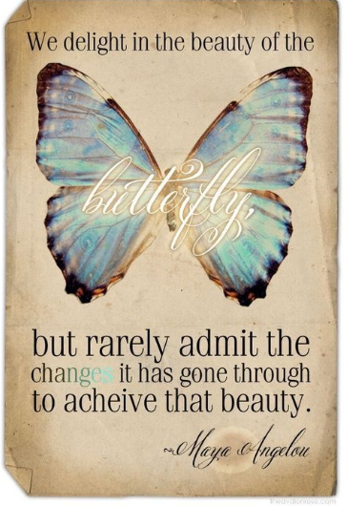
Due- The project is due Wednesday, May 3rd. Presentations will occur Wednesday-Friday next week.

