Name:___________________________________________ Grade:_________/10
Mrs. Powers Body Paragraph #1
ENG-8
2/16/17

Body Paragraph #1: The Barrier…
Directions: Write the 1st body paragraph of “The Breaking Barriers Essay”.
- HOOK- A riveting sentence or paragraph that draws in the reader’s attention.

Example:
- Supporting detail #1- Name the barrier you faced. Include details about the barrier.
- Supporting detail #2- When did you face the barrier? Who was involved in the situation? Elaborate- who, what, where, when, why, how.
- Closing Sentence- Summarize what your reader just learned about you and lead-into your next paragraph.
Language Requirement:
- Include a compound sentence, complex sentence, OR compound-complex sentence.
- Include at least 2 transitional expressions per paragraph.
- Describe an experience using at least 3 sensory words, twice.
Example:
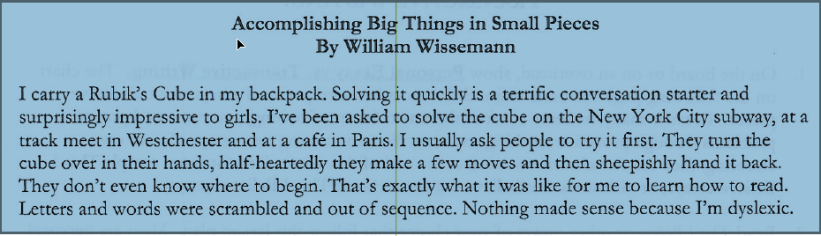

C_______________ U__________________P_____________________SP___________________________SS______________________

Hook:__________________________________________________________________________________________________________

__________________________________________________________________________________________________________________

__________________________________________________________________________________________________________________

__________________________________________________________________________________________________________________

__________________________________________________________________________________________________________________

__________________________________________________________________________________________________________________

__________________________________________________________________________________________________________________

__________________________________________________________________________________________________________________

__________________________________________________________________________________________________________________

__________________________________________________________________________________________________________________

__________________________________________________________________________________________________________________

__________________________________________________________________________________________________________________

__________________________________________________________________________________________________________________

__________________________________________________________________________________________________________________

__________________________________________________________________________________________________________________

__________________________________________________________________________________________________________________

