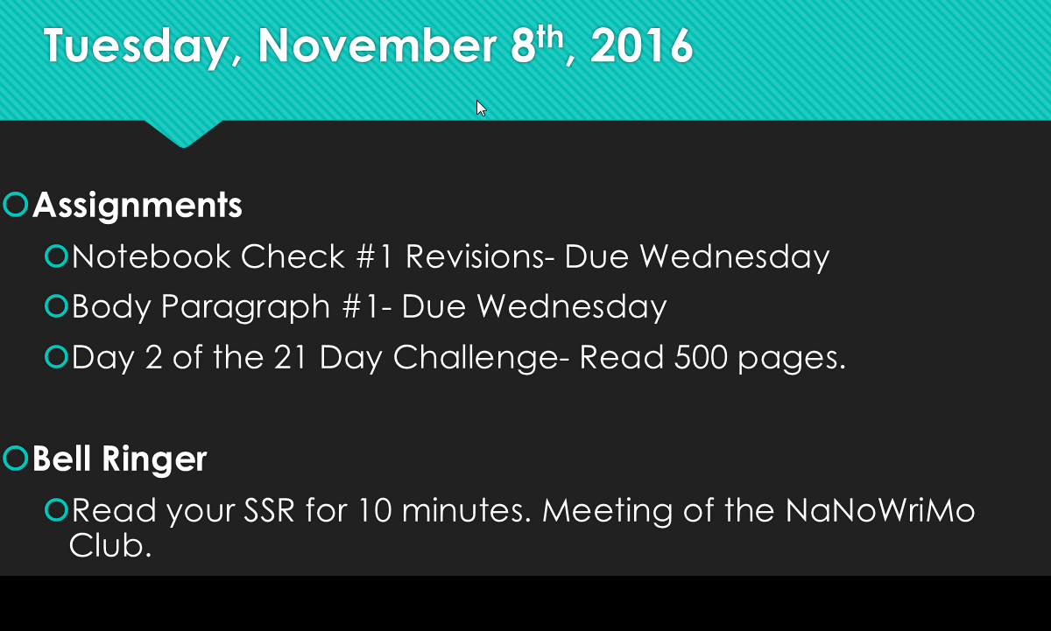

Name:___________________________________________ Grade:_________/10
Mrs. Powers Body Paragraph #1
ENG-8
11/7/16

Body Paragraph #1: Persuasive Speech
Directions: Write the 1st body paragraph of your Creature Speech. Please include the following in your introduction:
- Topic Sentence- A sentence that describes the first reason your creature should be adopted anecdote- story.
- Descriptive Details- Tell a cute story about you and your creature, showing your audience how much you love it. Include sensory details and vivid verbs.
- Closing Sentence- Summarize what was learned about the creature at the end of your story, and why it should be adopted.
Language Requirement:
- Include 1 compound sentence, 1 complex sentence, 1 compound-complex sentence.
- Highlight or Underline at least 10 sensory words/vivid verbs in your paragraph.
Example: My precious Tradly is in a band, but not just any band, Tradly is in THE LAMPS! Now when you think of lamps what comes to mind? (Ask an audience member). Well, that’s not the case! LAMPS is an acronym that stands for lovely, acoustic, mango, patterned, smoothiechow. I bet you have heard their latest single “Do you want to build a smoothichowman?” Tradly invited me on a tour with him and LAMPS, and let me tell you, every time they performed, it made me just want to “pretend” to cry. *SMILE AND SAY THAT MY BOY! He never seems to let me down; he is always there when I need him, and his offspring will be there for you as well!

C_______________ U__________________P_____________________SP___________________________SS______________________

_________________________________________________________________________________________________________________

__________________________________________________________________________________________________________________

__________________________________________________________________________________________________________________

__________________________________________________________________________________________________________________

__________________________________________________________________________________________________________________

__________________________________________________________________________________________________________________

__________________________________________________________________________________________________________________

__________________________________________________________________________________________________________________

__________________________________________________________________________________________________________________

__________________________________________________________________________________________________________________

__________________________________________________________________________________________________________________

__________________________________________________________________________________________________________________

__________________________________________________________________________________________________________________

__________________________________________________________________________________________________________________

__________________________________________________________________________________________________________________

__________________________________________________________________________________________________________________

__________________________________________________________________________________________________________________

__________________________________________________________________________________________________________________

__________________________________________________________________________________________________________________

Name:___________________________________________ Grade:_________/10
Mrs. Powers Body Paragraph #1
ENG-8
11/7/16

Body Paragraph #1: Informational Speech
Directions: Write the 1st body paragraph of your Creature Speech. Please include the following in your introduction:
- Topic Sentence- Explain what laboratory is responsible for the creature’s existence. State that the world is now a hazardous pace.
- Descriptive Details- Include three reasons why the world is a hazardous place as a result of your creature or why the creature is considered hazardous to the world.
- Closing Sentence- Summarize the three reasons why peoples’ lives on in peril.
Language Requirement:
- Include 1 compound sentence, 1 complex sentence, 1 compound-complex sentence.
- Highlight or Underline at least 10 sensory words/vivid verbs in your paragraph.

Example: Scientists at Create-A-Creature Labs, Inc. created this fearsome creature that has now escaped our laboratory and is multiplying uncontrollably. The first reason you should run for your lives is the chamelous absorbs elements. So it can turn into a fiery death serpent at any time it wants simply by touching fire. If that didn’t scare you, the fact that it’s an extremely ginormous monstrosity and is extremely hostile toward the human race definitely should. Not to mention the fact that it reproduces at super-sonic speed; almost like a Hydra with three heads. So, what happens when a large, rapidly-producing, element-absorbing creature who absolutely despises people happens to make MORE of itself? That could be what we in the science business call…REAALLLY FREAKING BAD!

C_______________ U__________________P_____________________SP___________________________SS______________________

_________________________________________________________________________________________________________________

__________________________________________________________________________________________________________________

__________________________________________________________________________________________________________________

__________________________________________________________________________________________________________________

__________________________________________________________________________________________________________________

__________________________________________________________________________________________________________________

__________________________________________________________________________________________________________________

__________________________________________________________________________________________________________________

__________________________________________________________________________________________________________________

__________________________________________________________________________________________________________________

__________________________________________________________________________________________________________________

__________________________________________________________________________________________________________________

__________________________________________________________________________________________________________________

__________________________________________________________________________________________________________________

__________________________________________________________________________________________________________________

__________________________________________________________________________________________________________________

__________________________________________________________________________________________________________________

__________________________________________________________________________________________________________________

__________________________________________________________________________________________________________________

Name:___________________________________________ Grade:_________/10
Mrs. Powers Body Paragraph #1
ENG-8
11/7/16

Body Paragraph #1: Entertaining Speech (Eulogy or Wedding Toast)
Directions: Write the 1st body paragraph of your Creature Speech. Please include the following in your introduction:
- Topic Sentence- Establish what kind of creature it was: funny, loyal, loving
- Descriptive Details- Elaborate on this by including a brief history of three key events from the creature’s life.
- Closing Sentence- Explain how the three events come together to give your creature their personality.
Language Requirement:
- Include 1 compound sentence, 1 complex sentence, 1 compound-complex sentence.
- Highlight or Underline at least 10 sensory words/vivid verbs in your paragraph.

Example: Beaster is very humorous (or so he thinks), and I can recollect some of his dates. He was twelves at the time, and he didn’t know how a date worked. So I told him to just be himself. Well, he definitely took that to an extreme. He dumped spaghetti on himself in front of his date because he intentionally wanted to show off by “flipping” out over cold pasta. When he was fifteen, he liked another girl. Beaster wanted to also impress her with his humor; therefore, he threw mud balls at himself. When he was eighteen, he just received a brand new bike. He went on his first date with Bearerina and his new bike. Well, he got stuck in the mud and called me to help. How embarrassing. All in all, I think Beaster is a little too familiar with embarrassment as a result of his humor.

C_______________ U__________________P_____________________SP___________________________SS______________________

_________________________________________________________________________________________________________________

__________________________________________________________________________________________________________________

__________________________________________________________________________________________________________________

__________________________________________________________________________________________________________________

__________________________________________________________________________________________________________________

__________________________________________________________________________________________________________________

__________________________________________________________________________________________________________________

__________________________________________________________________________________________________________________

__________________________________________________________________________________________________________________

__________________________________________________________________________________________________________________

__________________________________________________________________________________________________________________

__________________________________________________________________________________________________________________

__________________________________________________________________________________________________________________

__________________________________________________________________________________________________________________

__________________________________________________________________________________________________________________

__________________________________________________________________________________________________________________

__________________________________________________________________________________________________________________

__________________________________________________________________________________________________________________

__________________________________________________________________________________________________________________

